**Decision Making Statement in Java**

**Decision making statement** statements is also called selection statement. That is depending on the condition block need to be executed or not which is decided by condition. If the condition is "true" statement block will be executed, if condition is "false" then statement block will not be executed. In java there are three types of decision making statement.

* if
* if-else
* switch

**if-then Statement**

if-then is most basic statement of Decision making statement. It tells to program to execute a certain part of code only if particular condition is true.

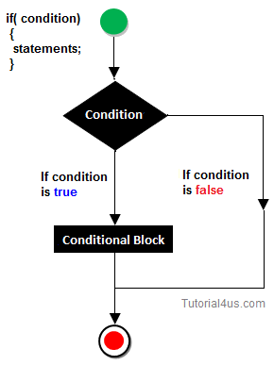

**Syntax**

if(condition)

{

Statement(s)

}

**Example if statement**

**class** Hello

{

**int** a=10;

**public** **static** **void** main(String[] args)

{

**if**(a<15)

{

System.**out**.println("Hello good morning!");

}

}

}

**Output**

Hello good morning

**if-else statement**

In general it can be used to execute one block of statement among two blocks, in java language **if**and **else** are the keyword in java.

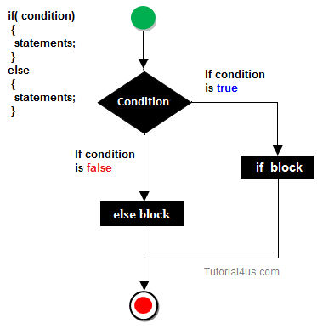

**Syntax**

if(condition)

{

Statement(s)

}

else

{

Statement(s)

}

........

In the above syntax whenever condition is true all the if block statement are executed, remaining statement of the program by neglecting. If the condition is false else block statement executed and neglecting if block statements.

**Example if else**

**import** java.util.Scanner;

**class** Oddeven

{

**public** **static** **void** main(String[] args)

{

**int** **no**;

Scanner s=**new** Scanner(System.**in**);

System.**out**.println("Enter any number :");

**no**=s.nextInt();

**if**(**no**%2==0)

{

System.**out**.println("Even number");

}

**else**

{

System.**out**.println("Odd number");

}

}

}

**Output**

Enter any number :

10

Even number

**Switch Statement**

The **switch** statement in java language is used to execute the code from multiple conditions or case. It is same like if else-if ladder statement.

A switch statement work with byte, short, char and int primitive data type, it also works with enumerated types and string.

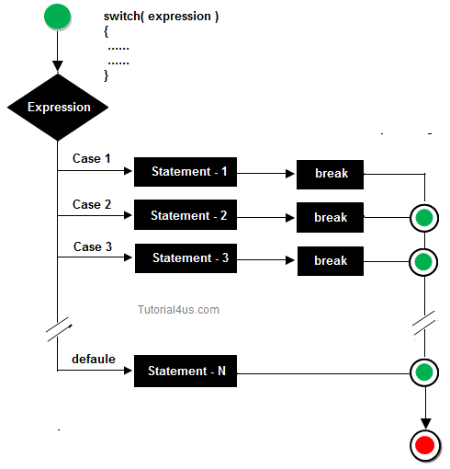

**Syntax**

switch(expression/variable)

{

case value:

//statements

// any number of case statements

break; //optional

default: //optional

//statements

}

**Rules for apply switch statement**

With switch statement use only byte, short, int, char data type (float data type is not allowed). You can use any number of case statements within a switch. Value for a case must be same as the variable in switch.

**Limitations of switch statement**

Logical operators cannot be used with switch statement. For instance

**Example**

**case** k>=20: // not allowed

**Example of switch case**

**import** java.util.*;

**class** switchCase

{

**public** **static** **void** main(String arg[])

{

**int** ch;

System.**out**.println("Enter any number (1 to 7) :");

Scanner s=**new** Scanner(System.**in**);

ch=s.nextInt();

**switch**(ch)

{

**case** 1:

System.**out**.println("Today is Monday");

**break**;

**case** 2:

System.**out**.println("Today is Tuesday");

**break**;

**case** 3:

System.**out**.println("Today is Wednesday");

**break**;

**case** 4:

System.**out**.println("Today is Thursday");

**break**;

**case** 5:

System.**out**.println("Today is Friday");

**break**;

**case** 6:

System.**out**.println("Today is Saturday");

**break**;

**case** 7:

System.**out**.println("Today is Sunday");

**default**:

System.**out**.println("Only enter value 1 to 7");

}

}

}

**Output**

Enter any number (1 to 7) :

5

Today is Friday

## Looping Statement in Java

**Looping statement** are the statements execute one or more statement repeatedly several number of times. In java programming language there are three types of loops; while, for and do-while.

### Why use loop ?

When you need to execute a block of code several number of times then you need to use looping concept in Java language.

### Advantage with looping statement

* Reduce length of Code
* Take less memory space.
* Burden on the developer is reducing.
* Time consuming process to execute the program is reduced.

### Difference between conditional and looping statement

Conditional statement executes only once in the program where as looping statements executes repeatedly several number of time.

## While loop

In **while loop** first check the condition if condition is true then control goes inside the loop body otherwise goes outside of the body. while loop will be repeats in clock wise direction.

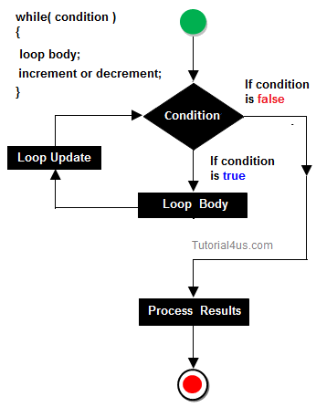

## Syntax

while(condition)

{

Statement(s)

Increment / decrements (++ or --);

}

## Example while loop

**class** whileDemo

{

**public** **static** **void** main(String args[])

{

**int** i=0;

**while**(i<5)

{

System.**out**.println(+i);

i++;

}

## Output

0

2

3

4

## for loop

**for loop** is a statement which allows code to be repeatedly executed. For loop contains 3 parts Initialization, Condition and Increment or Decrements

## Syntax

for ( initialization; condition; increment )

{

statement(s);

}

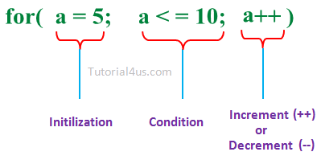

* **Initialization:**This step is execute first and this is execute only once when we are entering into the loop first time. This step is allow to declare and initialize any loop control variables.
* **Condition:**This is next step after initialization step, if it is true, the body of the loop is executed, if it is false then the body of the loop does not execute and flow of control goes outside of the for loop.
* **Increment or Decrements:**After completion of Initialization and Condition steps loop body code is executed and then Increment or Decrements steps is execute. This statement allows to update any loop control variables.

### Flow Diagram

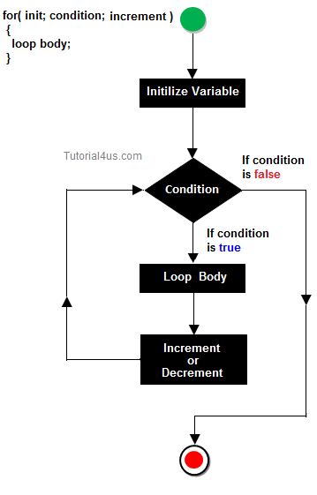

## Control flow of for loop

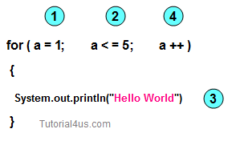

* First initialize the variable
* In second step check condition
* In third step control goes inside loop body and execute.
* At last increase the value of variable
* Same process is repeat until condition not false.

Improve your looping concept[For Loop](https://www.sitesbay.com/cprogramming/c-for-loop)

### Display any message exactly 5 times.

## Example of for loop

**class** Hello

{

**public** **static** **void** main(String args[])

{

**int** i;

**for** (i=0: i<5; i++)

{

System.**out**.println("Hello Friends !");

}

}

}

## Output

Hello Friends !

Hello Friends !

Hello Friends !

Hello Friends !

Hello Friends !

## do-while

A **do-while** loop is similar to a while loop, except that a do-while loop is execute at least one time.

A do while loop is a control flow statement that executes a block of code at least once, and then repeatedly executes the block, or not, depending on a given condition at the end of the block (in while).

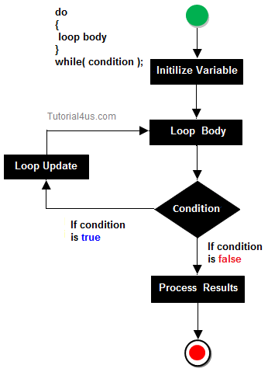

### When use do..while loop

when we need to repeat the statement block **at least one time** then use do-while loop. In do-while loop post-checking process will be occur, that is after execution of the statement block condition part will be executed.

## Syntax

do

{

Statement(s)

increment/decrement (++ or --)

}while();

In below example you can see in this program i=20 and we check condition i is less than 10, that means condition is false but do..while loop execute onec and print Hello world ! at one time.

## Example do..while loop

**class** dowhileDemo

{

**public** **static** **void** main(String args[])

{

**int** i=20;

**do**

{

System.**out**.println("Hello world !");

i++;

}

**while**(i<10);

}

}

## Output

Hello world !

## Example do..while loop

**class** dowhileDemo

{

**public** **static** **void** main(String args[])

{

**int** i=0;

**do**

{

System.**out**.println(+i);

i++;

}

**while**(i<5);

}

}

## Output

1

2

3

4

5